National Library of Scotland online maps maps.nls.uk
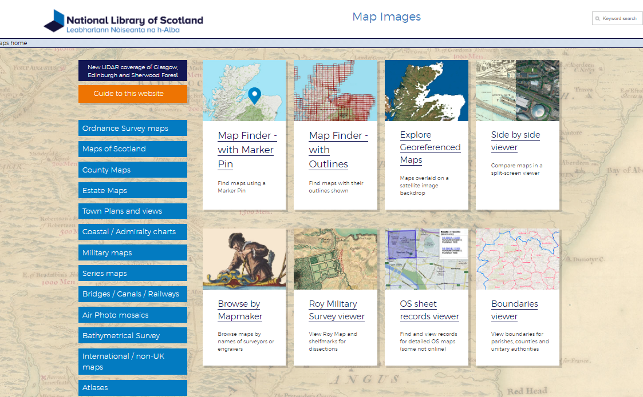
A number of ways to find the maps:
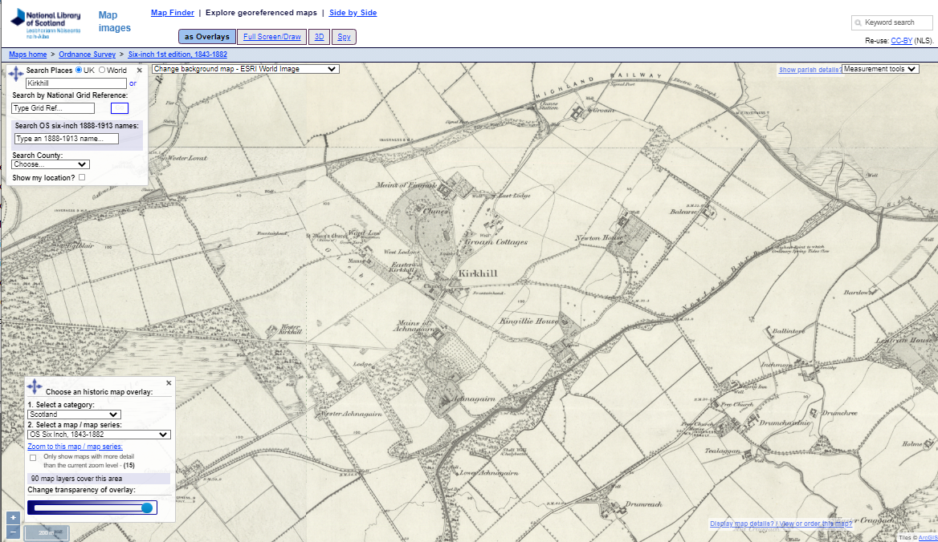
Georeferenced maps: a way to overlay historical and modern (can also do side by side)

1. Type in place/grid ref

2. Select modern map/view from list

3. Set category to Scotland
4. Choose historic map from list
5. Toggle between views

Scrolling: using + and – or mouse wheel Grid reference will appear here as you move the cursor around
HELP is available on many screens in the lower left (orange tab)

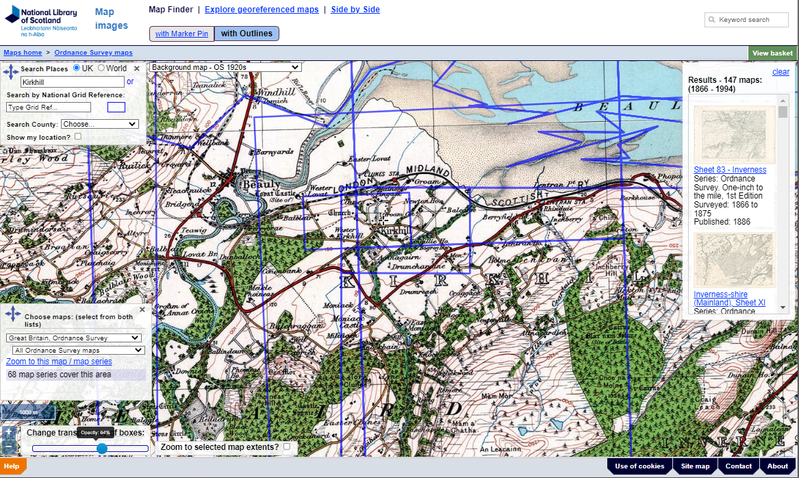
Using maps which require you to choose sheets (where they have not been ‘stitched’ together, eg OS 25” to a mile 1st edition)

1. Choose place as with georeferenced maps
2. Choose at bottom left the map(s) you wish to see
3. Zoom in on the base map if necessary. The sheets are outlined in blue
4. From the list on the right, choose the sheet you want. Note that the list can be quite long. In the example here there are 147 maps which qualify

Selecting Maps from lists
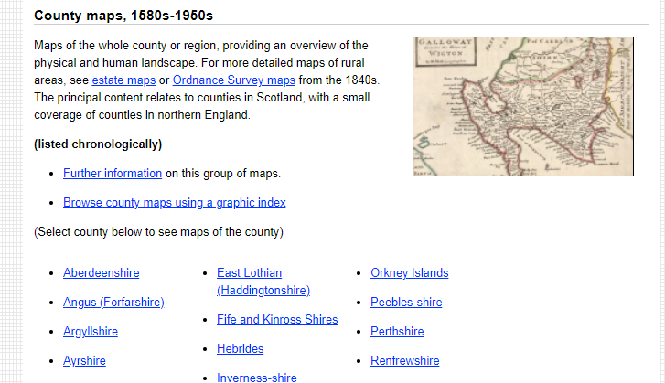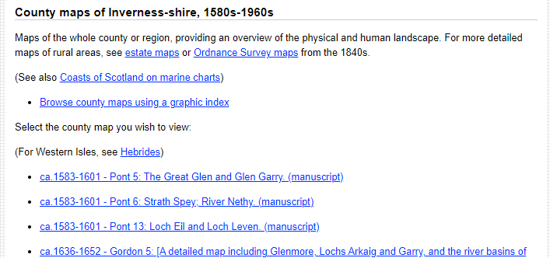
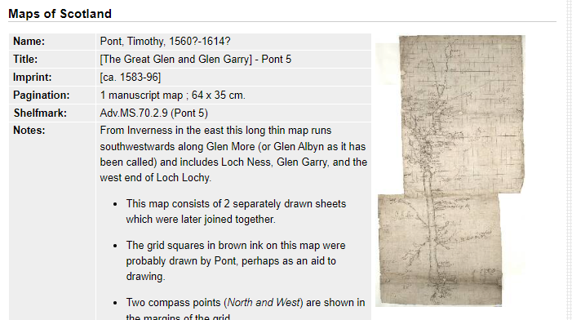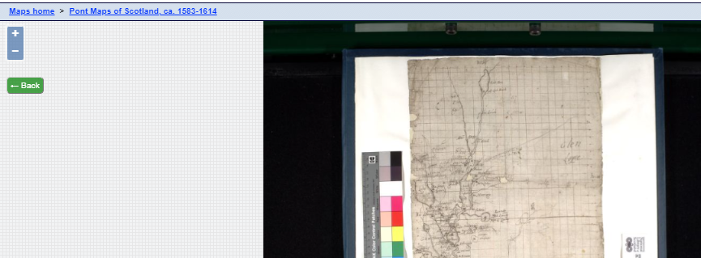
Click on map to open Use + or - or mouse to zoom

